Assignment 1: SQL1:
For the following relational model:
Student(sid, fname, lname, gpa)
Course ( cid, code, name, credithours)
Enrolled (sid, cid,grade)
Write SQL queries for the following:
Print students' names ordered desc by their GPA.
Print all the computer sciences courses, these courses with code starting with ‘CS’ sorted alphabetically.
Print all the students with a GPA less than 3.0
Print all the students with a GPA of a least 3.0
Find all students that have enrolled in the database course
Find all the students that have (A or more) at least once
Find all students that has enrolled in 'Database' Course' and got at least B

- Preface/Setup

- Create a schema
- Name it College_Students
- Create a table for
- Student
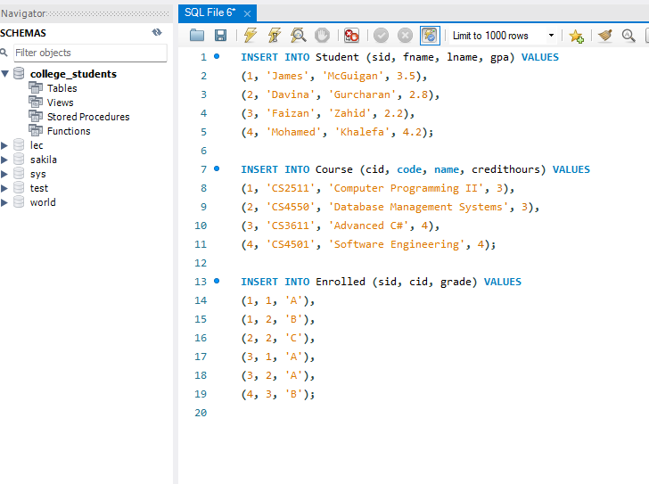
- Course
- Enrolled
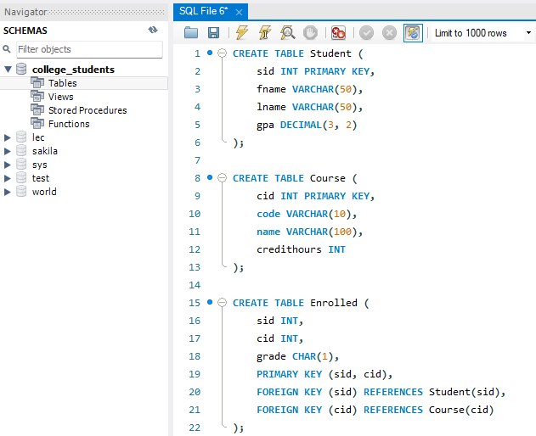
- Insert information for each

- Print students' names ordered desc by their GPA.
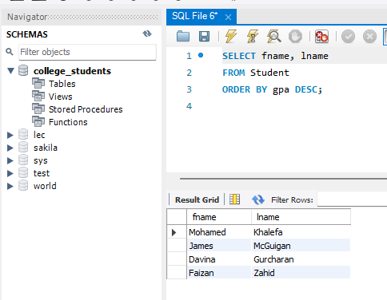

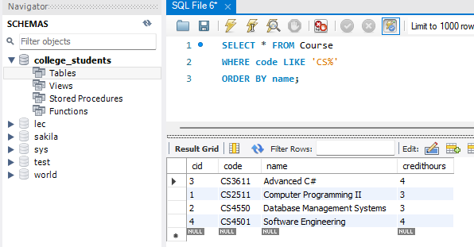
- Print all the computer sciences courses, these courses with code starting with ‘CS’ sorted alphabetically.

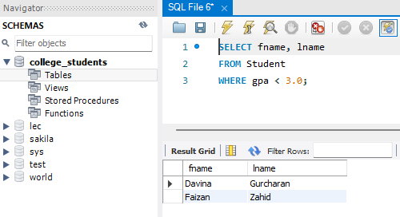
- Print all the students with a GPA less than 3.0:

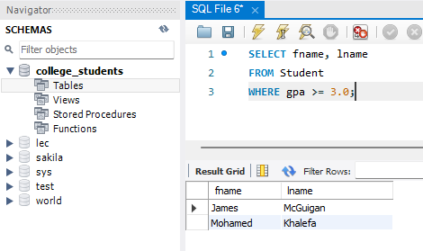
- Print all the students with a GPA of a least 3.0:

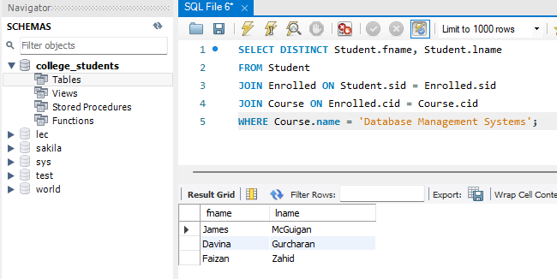
- Find all students that have enrolled in the database course:

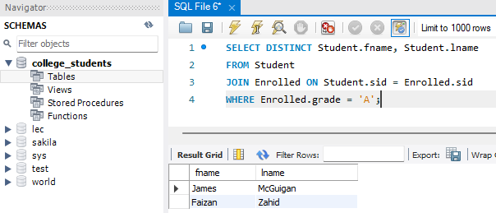
- Find all the students that have (A or more) at least once:

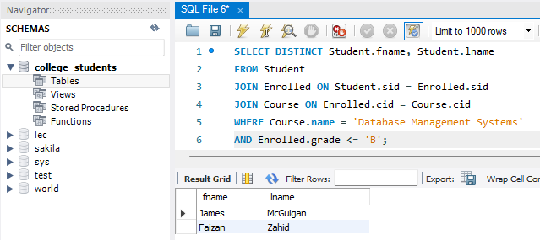
- Find all students that has enrolled in 'Database' Course' and got at least B:

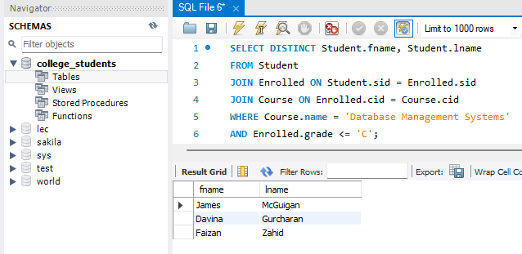
- Find all students that has enrolled in 'Database' Course' and got at least C to Check over Question 7:

